The catalog contents of M1M spare parts (12 Volt):

Page01 Engine assembly 1
Page02 Engine assembly 2
Page03 Engine assembly 3

Page04 Air intake system
Page05 Reverse Gearbox assembly 1
Page06 Reverse Gearbox assembly 2
Page07 Rear driving system assembly
Page08 Engine accessories and acoustical accessories

Page09 Battery, flexible shaft, speedometer relay adjustor, carburettor
Page10 Lighting
Page11 Wheel assembly and front wheel brake
Page12 Front fork assembly 1
Page13 Front fork assembly 2
Page14 Frame assembly 1
Page15 Frame assembly 2
Page16 Petrol tank assembly and exhaust pipe silencer
Page17 Direction control device and rear brake device
Page18 Seat cushion
Page19 Cable
Page20 Side-car frame
Page21 Side wheel shaft rocker arm device
Page22 Side-bucket

Engine assembly 1

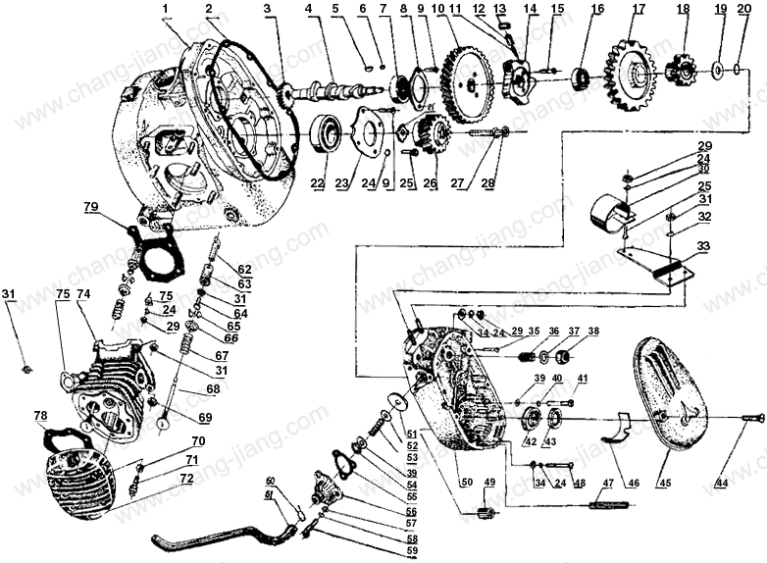

Engine assembly 2

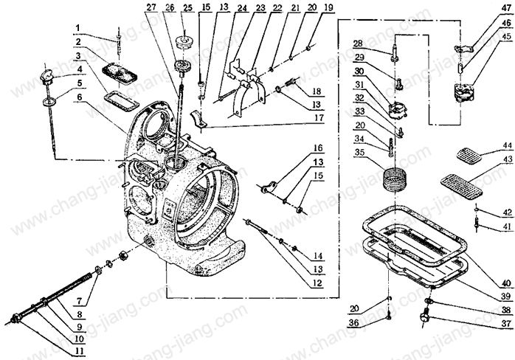

Engine assembly 3

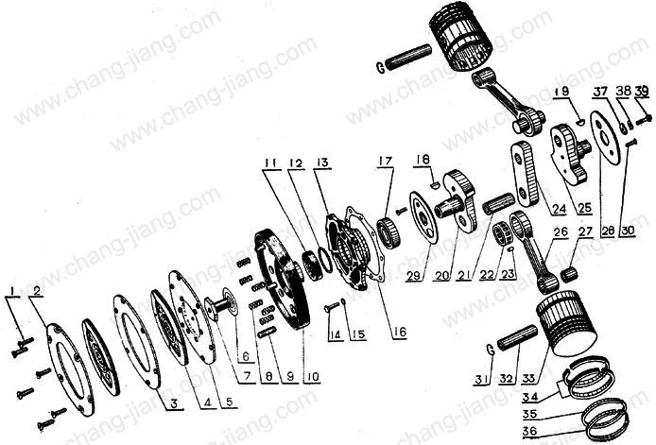

Air intake system

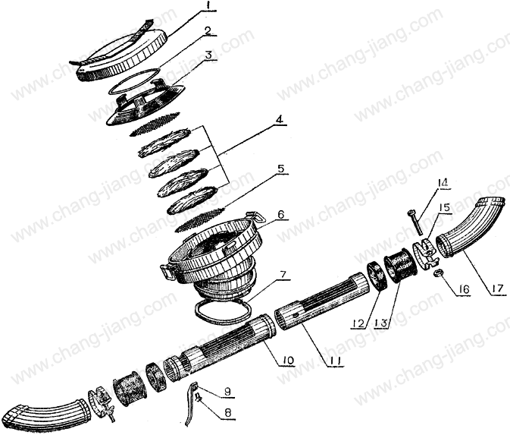

Reverse Gearbox assembly 1

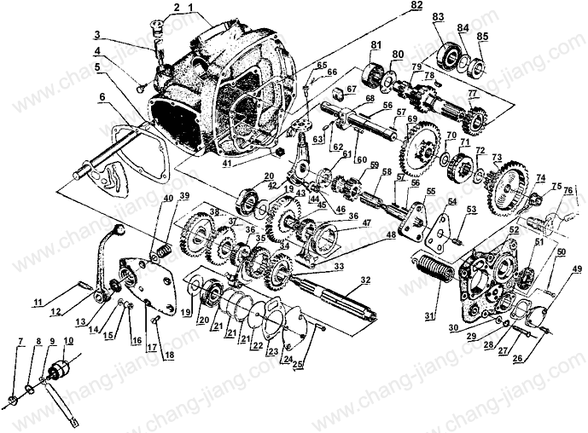

Reverse Gearbox assembly 2

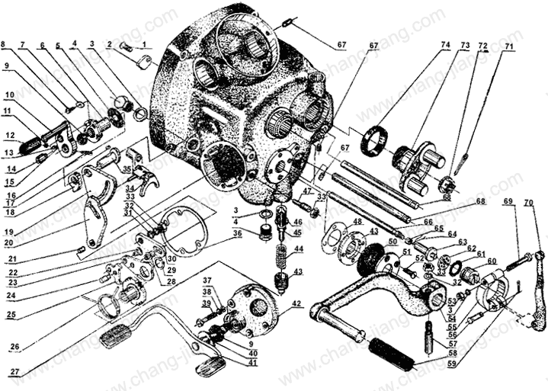

Rear driving system assembly

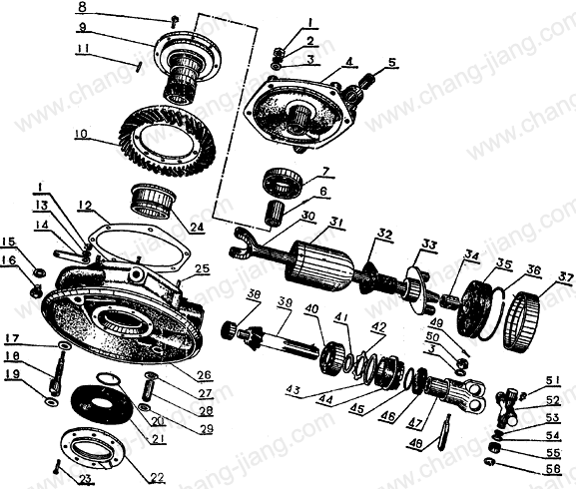

Engine accessories and acoustical accessories

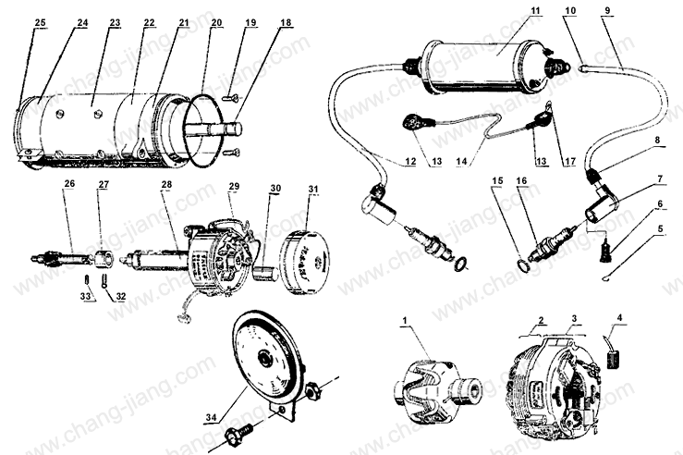

Battery, flexible shaft, speedometer relay adjustor, carburettor

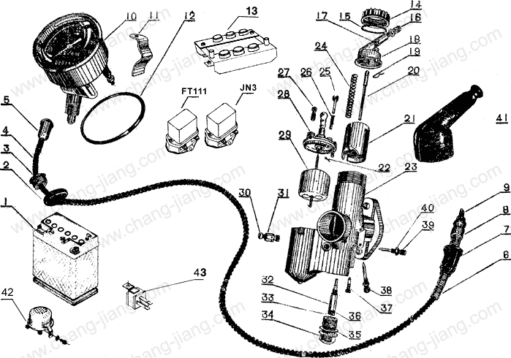

Lighting

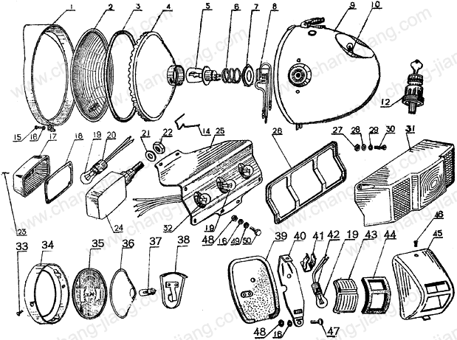

Wheel assembly and front wheel brake

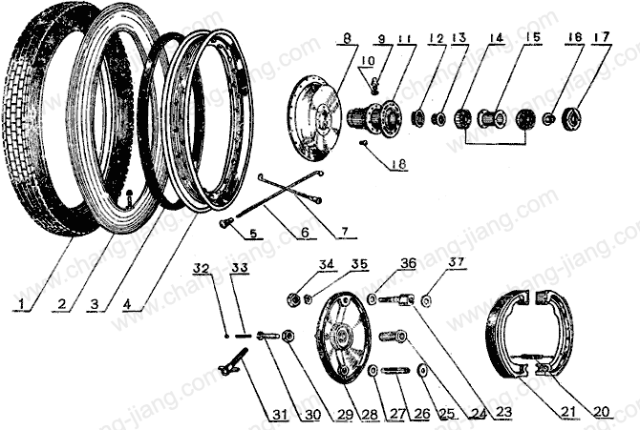

Front fork assembly 1

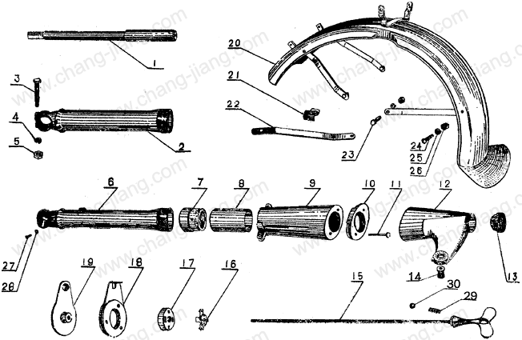

Front fork assembly 2

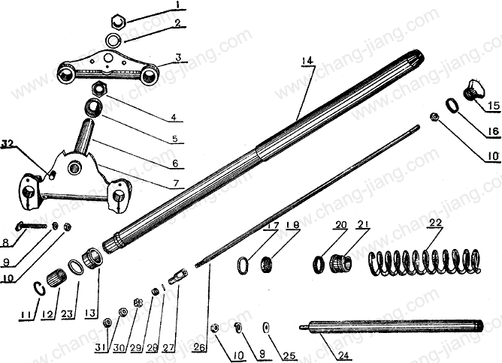

Frame assembly 1

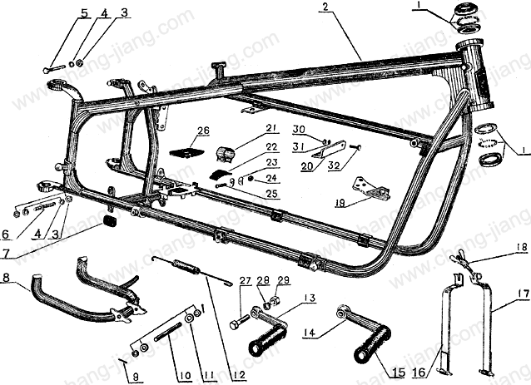

Frame assembly 2

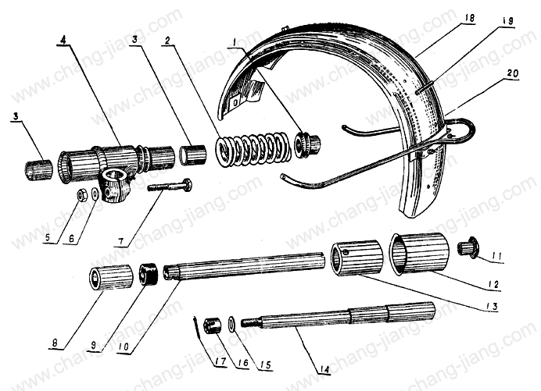

Petrol tank assembly and exhaust pipe silencer

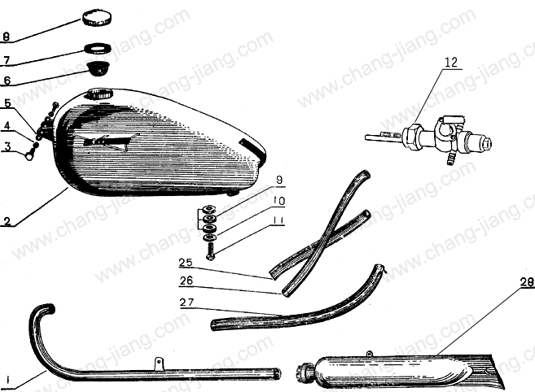

Direction control device and rear brake device

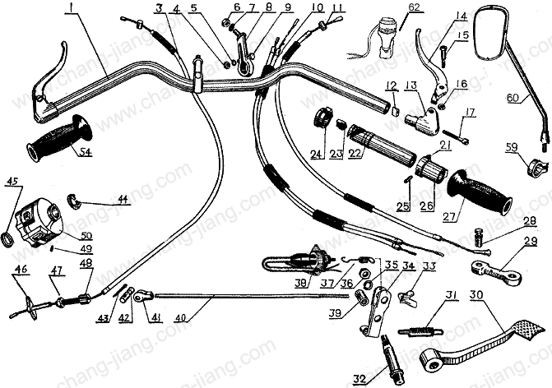

Seat cushion

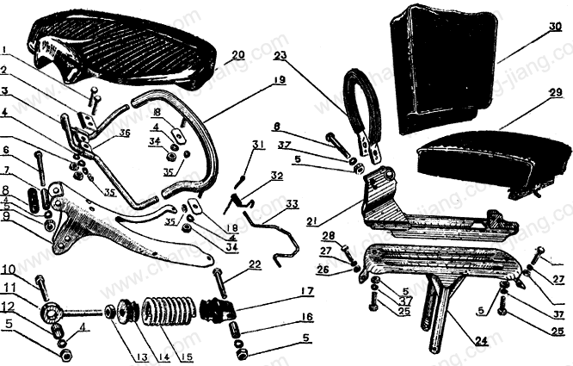

Cable

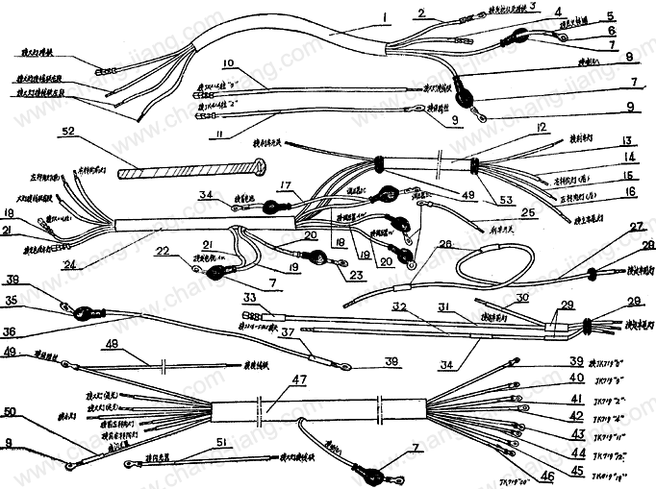

Side-car frame

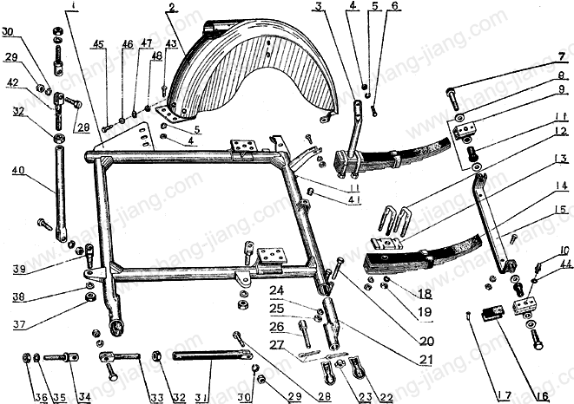Side-car frame

Side wheel shaft rocker arm device

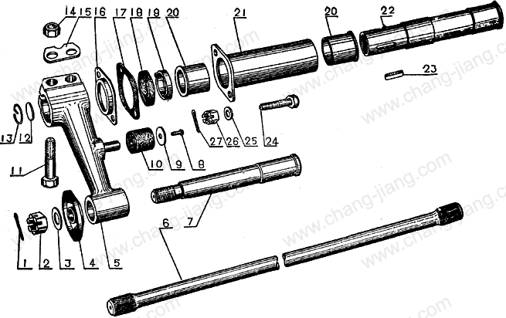

Side bucket

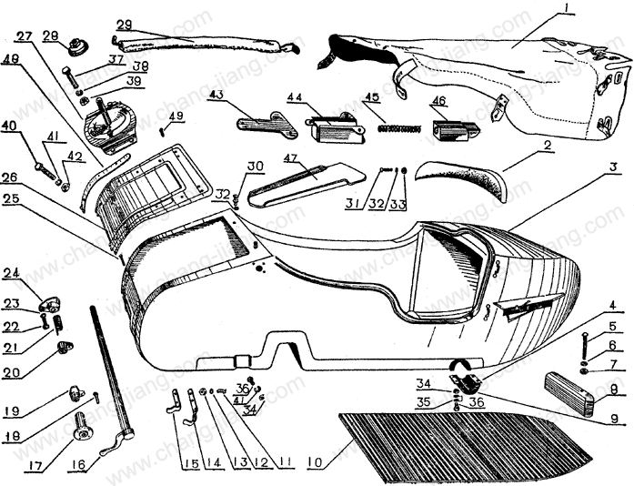

CJ 750 M1M electrical circuit – cabling diagram

